Code:

import java.util.Scanner;

public class Recursive {

public static int multiplyNumbers(int[] numbers, int index){

if(index == numbers.length -1){

return numbers[index];

}

return numbers[index] \* multiplyNumbers(numbers, index + 1);

}

public static void main(String[] args){

Scanner inputScanner = new Scanner(System.in);

int[] inputNumbers = new int[5];

System.out.println("Please enter 5 integers");

for(int i = 0; i < inputNumbers.length; i++){

System.out.println("Number " + (i+1)+":");

inputNumbers[i] = inputScanner.nextInt();

}

int total = multiplyNumbers(inputNumbers, 0);

System.out.println("Total is: " + total);

inputScanner.close();

}

}

Screenshots:

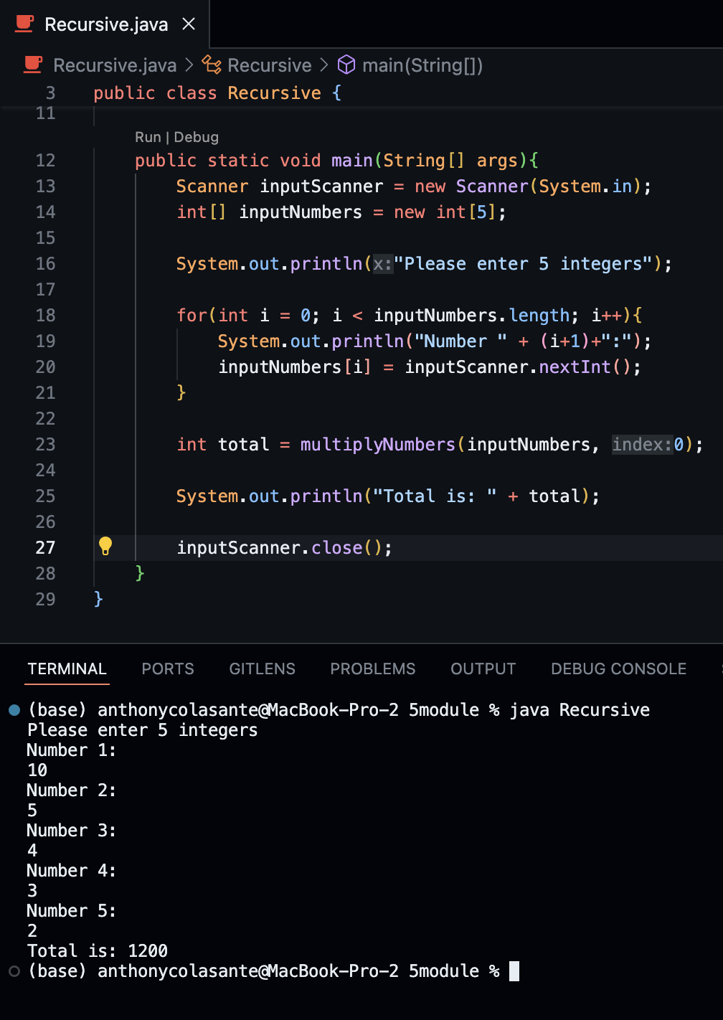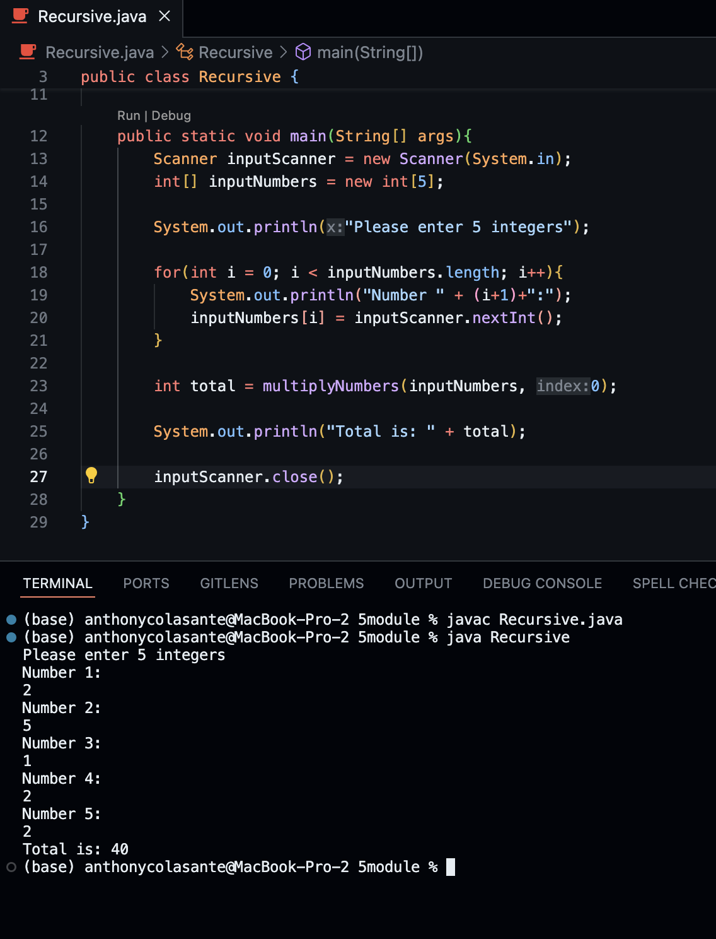

Github Repo: <https://github.com/cocacolasante/5module>